**Qwik Events Comments and Bugs Updated**

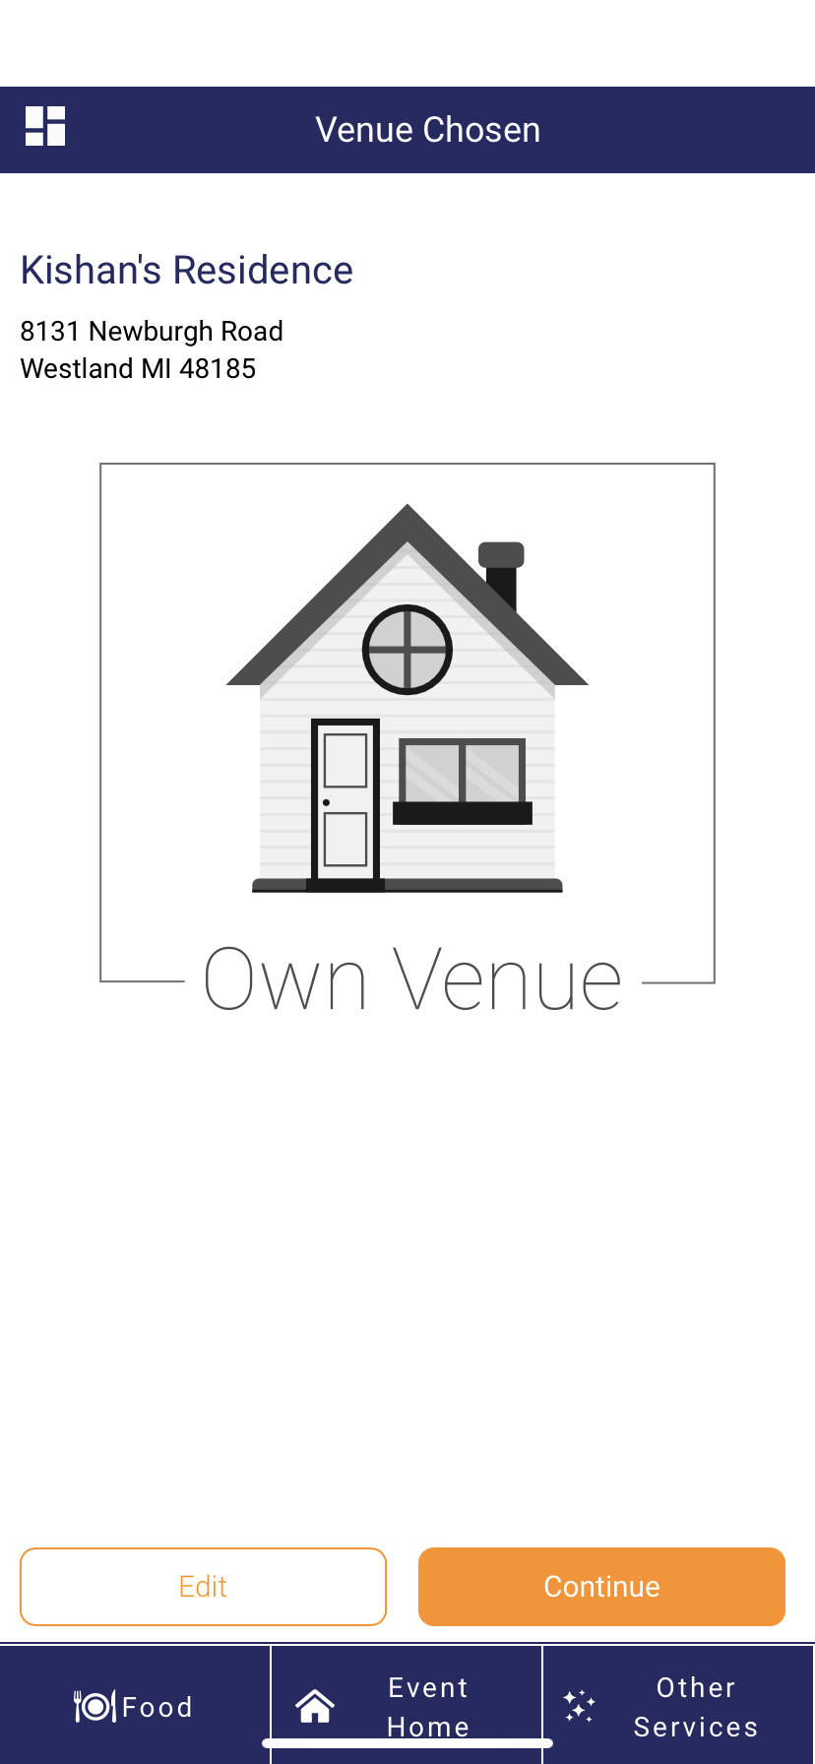

**Buttons on the bottom bar are too low (they intercept with the home indicator bar on the iPhone X+)**

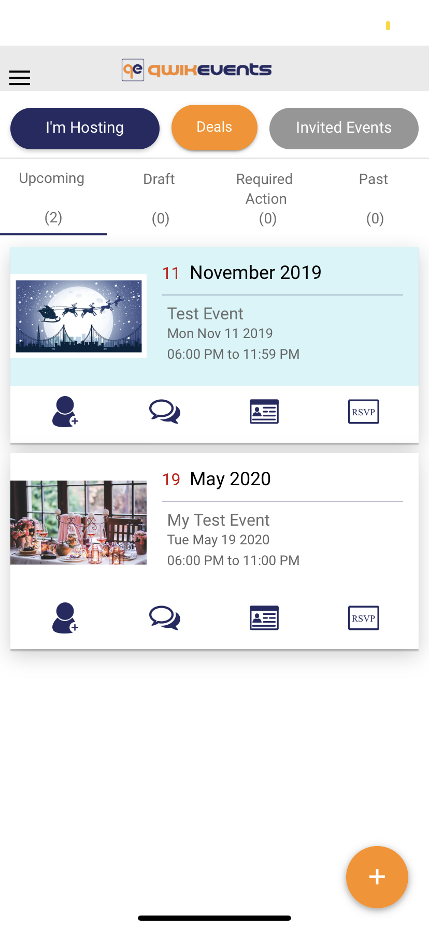

**The top bar is white which makes it very difficult to see the time (top-left) and the battery status (top-right)**

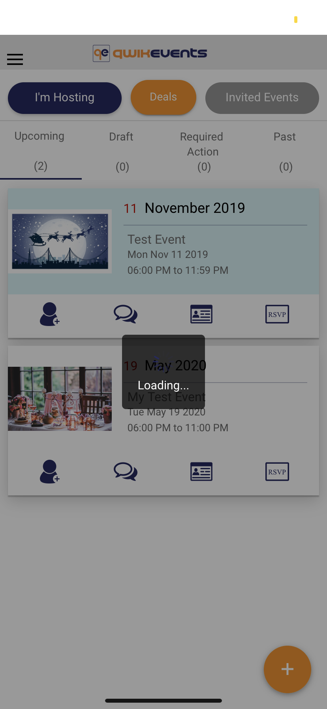

**The main page reloads every time I leave it and come back to it (is it supposed to?)**

**Wouldn’t it be more efficient not to load it every time?**

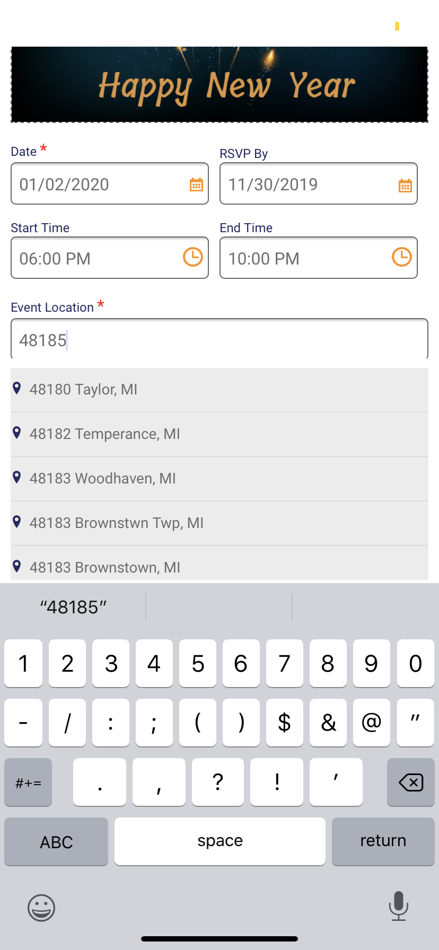

**Event Location api call based on zip code does not provide right results sometimes (just a small bug)**

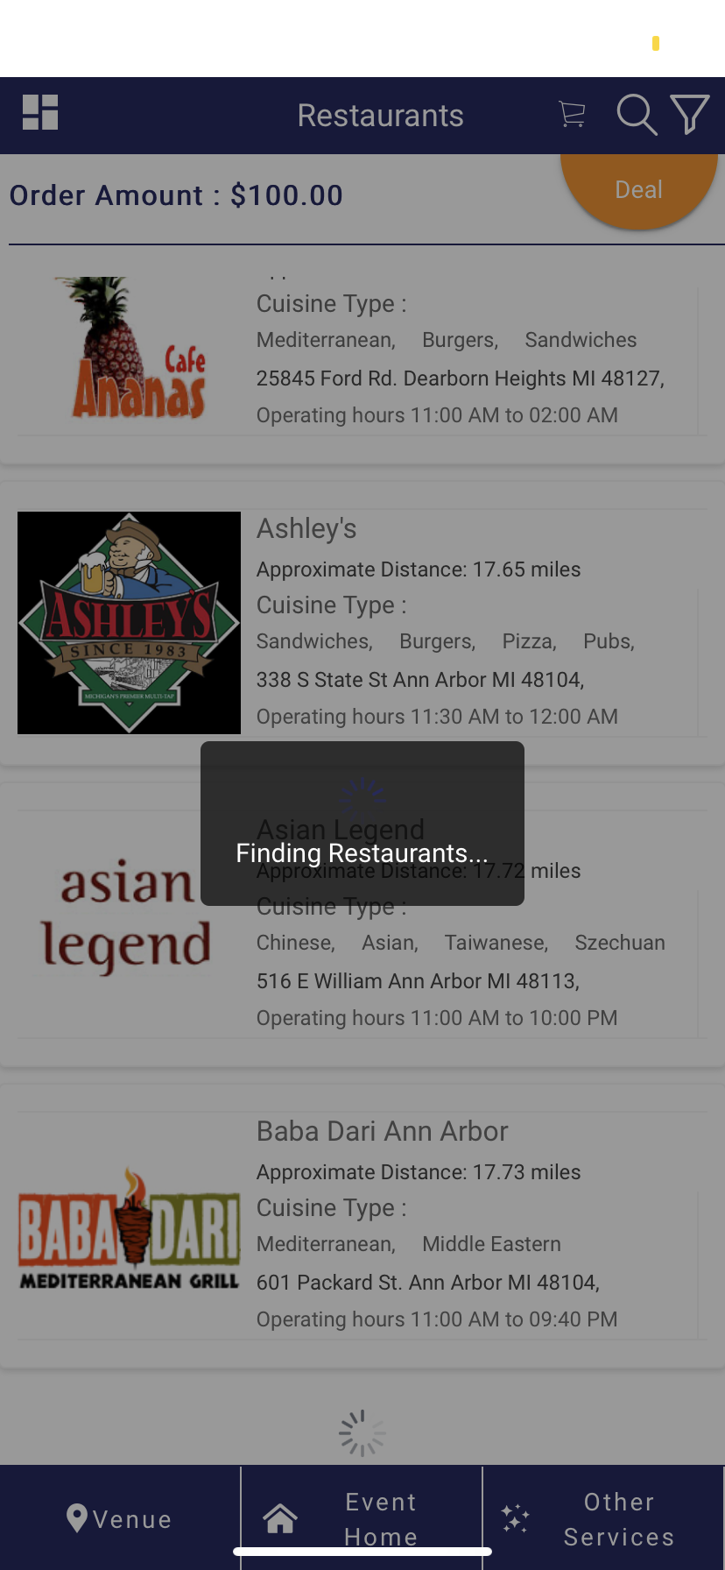

**As a user, I would like to scroll the page even when it is loading more restaurants or services**

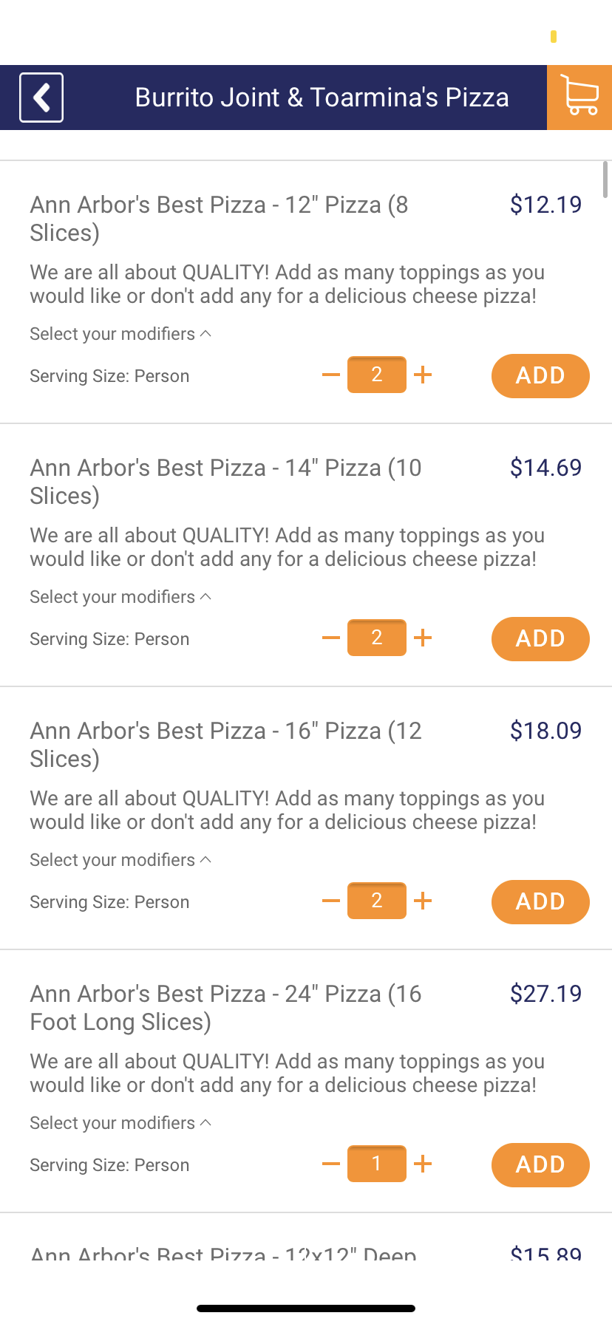

**The plus and minus buttons for each food item is a bit small (it’s hard to click them)**

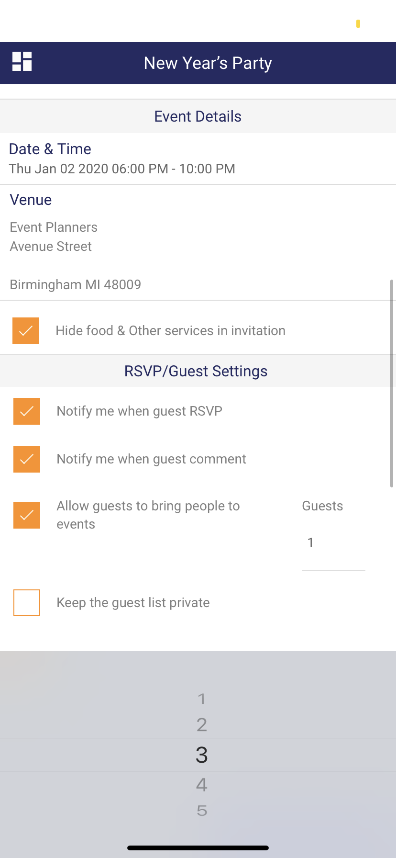

**All dropdown lists are missing a done button; clicking the option does not choose the value or close the list**

**When I clicked on the list element again it changed the value correctly but I could not close the list unless I find some whitespace anywhere on the page to click**

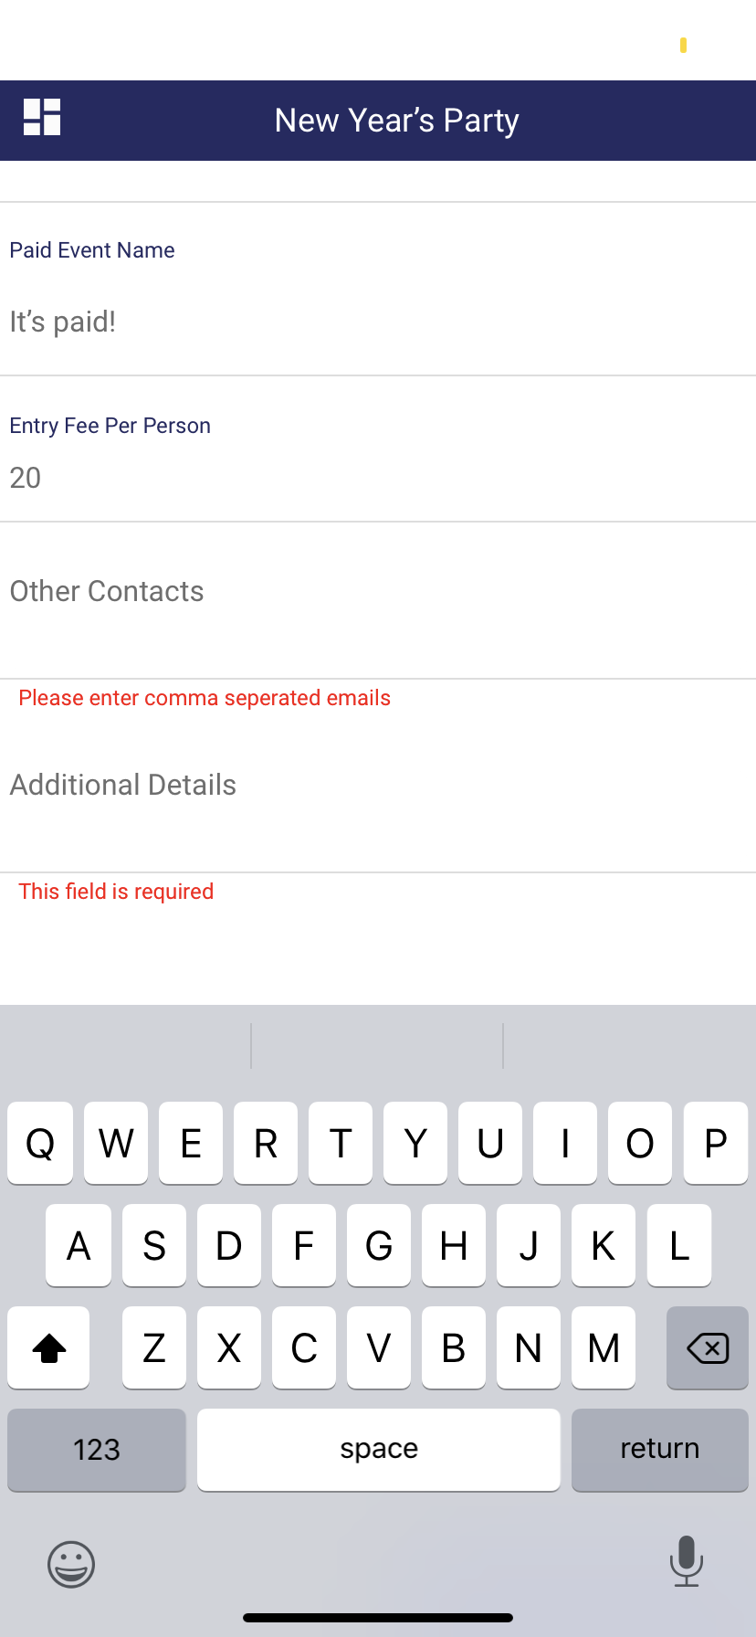

**In Edit Event page, is Additional Details a required field?**

**Also, the return button in Additional Details field works as an ‘enter’ button and thus there is no way to close the keyboard unless I click some whitespace on the page**

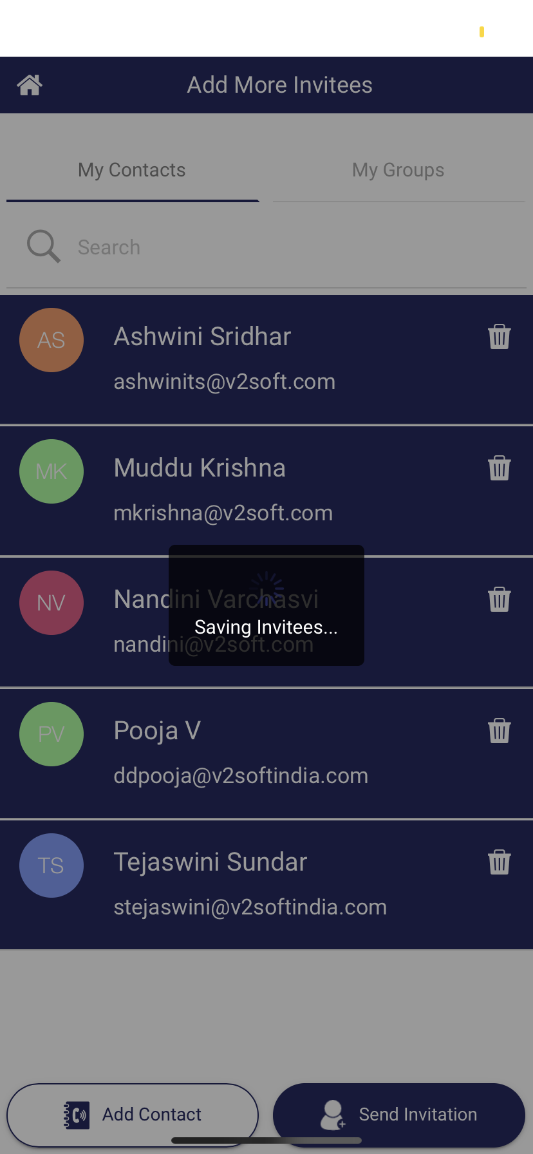

**I added my list of invitees and clicked ‘Send Invitation’ (continued in next image below)**

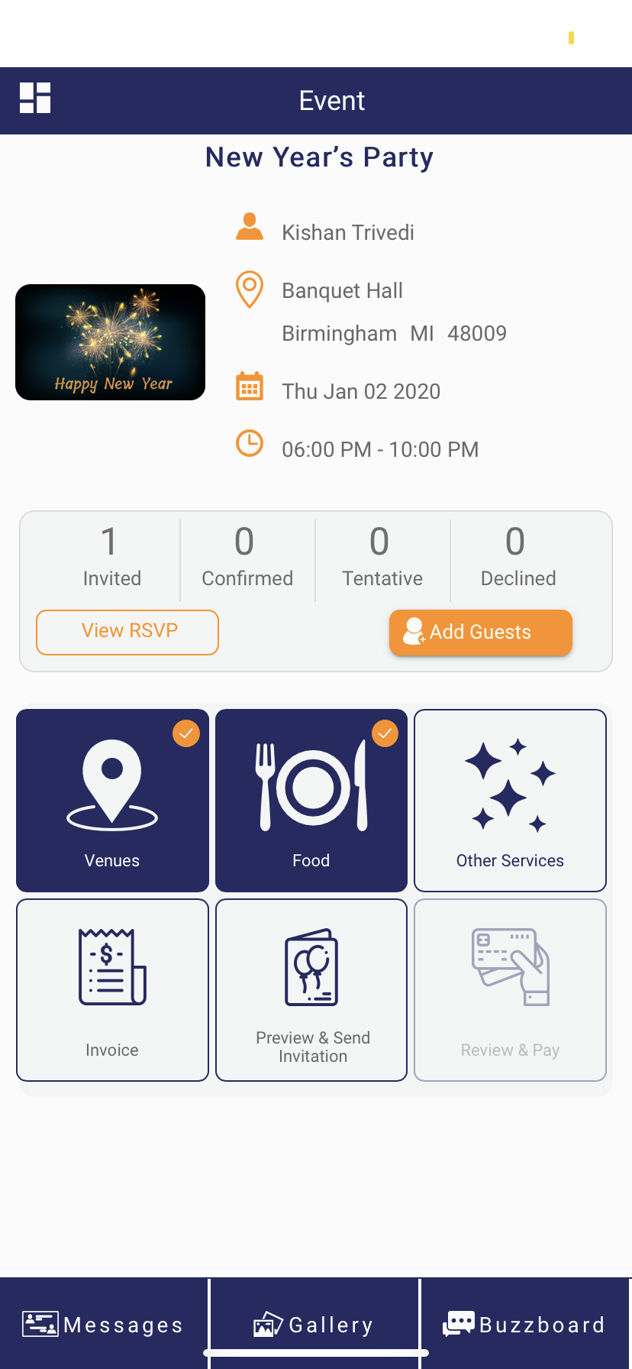

**It said invitations are sent but only one person was invited. The person invited was also not one from the list I chose (see image below this one). This is a major bug that needs to be fixed since it prevents users from inviting their guests successfully.**

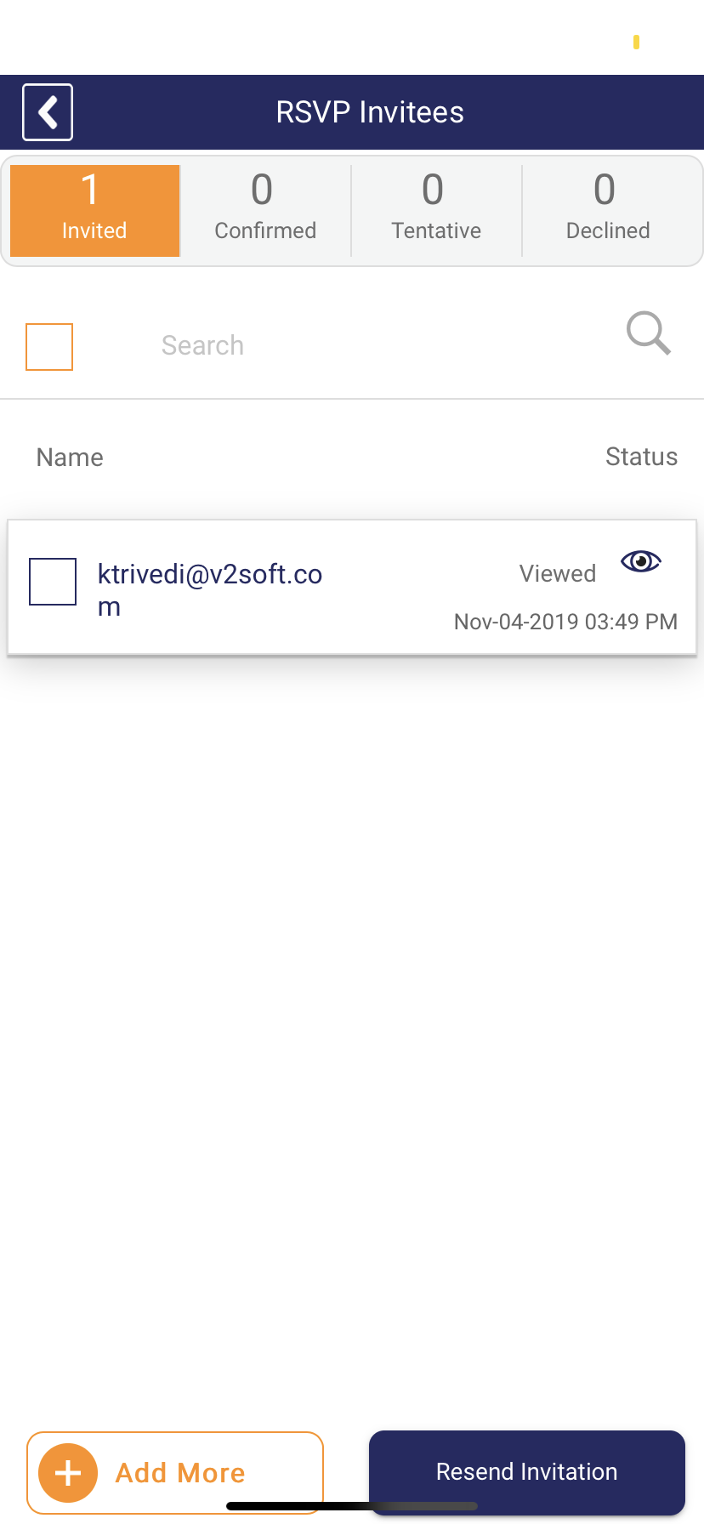

**The only invitation from the previous images was to my email address. My account is signed up with** [**ktrivedi@v2soft.com**](mailto:ktrivedi@v2soft.com) **and this invitation was also sent to that somehow. I did receive an email about the RSVP as well. Another major bug where one can send an invitation to themselves?**

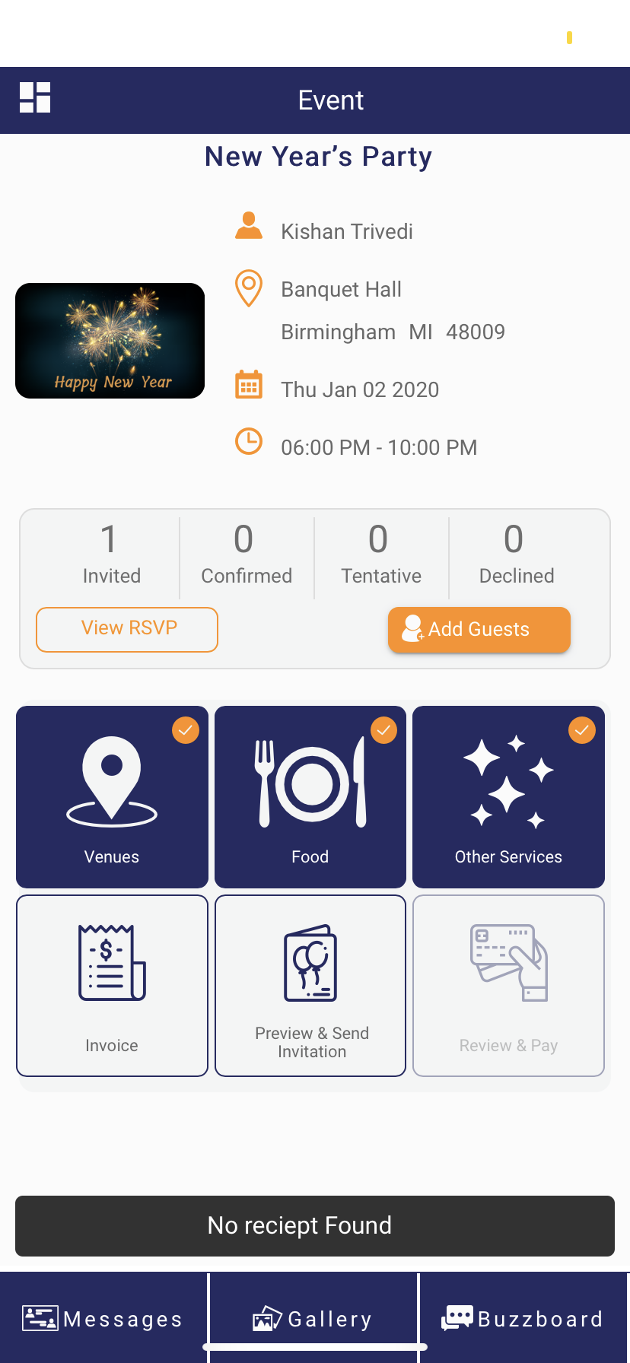

**I chose a paid venue, a restaurant for catering food, and a paid service as well but I was unable to open the Invoice. Every time I clicked on it, it just said ‘No receipt Found’ as it shows in the image above.**

**Further Notes**

**Receive a notification (either on the phone screen or in the App itself) when an event invitation is received**

* **Maybe a simple bubble over the 'Invited Events' Button with the number of invitations that are still pending**

**Once an invitee is added by clicking ‘Add Invitees’ button on the Add Invitees page, it can no longer be deleted (unless I send the invitations out immediately)**

* **When I click on the delete invitee button next to an invitee’s contact, it says ‘Invitee removed successfully’ but when I click back and then come back to the Add Invitees page, that invitee’s contact is highlighted again**

**Events have to start and end on the same day**

* **Can Events last longer than 1 day?**